**MADRAVENTURE**

**Abstract**

In the contemporary age, tourism platforms need to offer smooth, trustworthy, and complete services to improve traveler experiences. Madraventure is an online solution that **aims to revolutionize tourism in Chennai** by linking tourists with local guides, rental services, and expert travel information. Conventional travel planning tends to be marred by issues like untrustworthy guide services, disjointed rental services, and a lack of organized information. Madraventure meets these challenges with a **Local Guide Module** for **recruitment and registration of guides, a Rental Module for simple access to automobiles, electronics, and furniture, and an Explore Blog featuring major attractions.** Beyond this, the platform also brings economic opportunities for students and locals with the ability to engage the tourism sector. Future development involves an **admin dashboard, secure payment gateway integration, and mobile app development**, providing greater accessibility, transparency, and efficiency. By filling the gap between tourists and local service providers, Madraventure **encourages sustainable tourism and economic development in Chennai.**

**1 Introduction**

Tourism acts as a stimulant for economic development, cross-cultural exchange, and community empowerment, but visitors frequently experience hardships in gaining access to accurate information, meeting reputable local guides, and obtaining basic services. Madraventure is an online tourism portal intended to transform the travel experience in Chennai by blending three essential services**: Local Guide Module, Rental Services, and Explore Blog.**

Local guides are also instrumental in enriching tourism by providing genuine insights into historical sites, cultural practices, and unadvertised attractions that regular travel guides tend to miss. In a place like Chennai—famous for ancient temples, colorful festivals, picture-perfect beaches, and vibrant urban landscape—local guides offer individualized experiences that turn a usual visit into an intimate odyssey. Madraventure not only makes tourist interactions easier but also provides sustainable **economic opportunities through facilitating students and locals to earn from guided tours and rental services.**

Beyond facilitating convenience for travelers, Madraventure fosters local engagement, economic sustainability, and digital inclusivity by leveraging structured tourism services. Future enhancements such as an admin dashboard, secure payments, and mobile app integration will further optimize efficiency, security, and accessibility, making Madraventure a pioneering platform in Chennai’s tourism

**2 Literature Review**

The research focuses on developing a smart travel guide app for Madura Island to promote tourism and assist visitors. The mobile-based app provides navigation, tourist spot details, and culinary recommendations, integrating Google Maps for easy exploration. A survey of 30 respondents showed the app is helpful, and future enhancements will include ticket prices, visitor rush hour charts, and accommodation details. The software used includes Android Studio, Firebase, and Google Maps API, while the hardware consists of Android smartphones and GPS-enabled devices.[1]

The Smart Travel Guide Application is a dynamic online platform designed to enhance travel experiences by providing real-time navigation, personalized recommendations, and seamless user interaction. Developed using PHP, HTML, CSS, Bootstrap, and integrated database technologies like Firebase and PostgreSQL, the system ensures an intuitive and responsive interface. The hardware requirements include a quad-core 1.5GHz processor, 2GB RAM, and 16GB storage, while the software runs on Windows 10 with Flutter as the front-end framework. By leveraging AI, ML, and NLP, future enhancements aim to optimize user experiences, expand geographical coverage, and introduce advanced features for travelers.[2]

The "Bon Voyage" travel guide is a cross-platform web application with an integrated chatbot designed to assist travelers in planning trips, finding attractions, sharing experiences, and ensuring safety. It provides real-time information about risk-prone areas, essential travel items, and health precautions. The system is built using ReactJS for the frontend, Node.js for backend scripting, Google Maps API for location tracking, Firebase Authentication for secure user login, and Cloud Firestore for database management. Additional tools such as OpenWeatherMap API for weather updates , Highcharts for data visualization, and Google Voice Search enhance the user experience.[3]

The Journey Companion is an Android travel and tourism application designed to assist travelers by integrating multiple travel-related features into a single platform. It provides city information, weather forecasts, hotel listings, monument details, geolocation-based services, currency conversion, and more. The app follows the Model-View-Presenter (MVP) architecture and utilizes Object-Oriented Programming (OOP) principles. It runs on Android OS (minimum SDK version 22, target SDK 28) and requires at least 2GB RAM, 50MB storage, GPS, magnetometer, internet connectivity, and a touchscreen device. The app leverages SQLite for local storage and various APIs for fetching real-time data like weather, hotels, and tourist information. Security measures include MD5 hashing for password protection and communication via HTTPS services.[4]

The interactive platform for sharing travel guides, developed using Java and the Spring Boot framework, integrates Vue and UniApp for the front-end, MyBatisPlus for data persistence, and MySQL for database management. It allows users to share travel experiences, access multimedia content, perform keyword searches, receive personalized recommendations, and engage through comments and likes. The system was developed using IntelliJ IDEA on Windows 10, with supporting technologies like Maven, Knife4j for API documentation, and Shiro+JWT for security. Through these advancements, the platform enhances user interaction and simplifies access to travel information.[5]

**3 Methodology:**

Madraventure is developed through a systematic Software Development Lifecycle (SDLC) to provide an integrated and effective platform. Requirement Analysis starts the process, highlighting key functionalities like user authentication, hiring local guides, rental facilities, and an explore blog to improve the tourist experience. The System Design process includes organizing the database in MySQL and defining tables for user information, rental items, and guide services. In Implementation, the frontend is constructed with HTML, CSS, Bootstrap, and React.js, and the backend runs on Node.js with a WAMP local server for database handling. Some critical libraries are included, such as CORS for secure API handling, Multer for file uploads, Body-Parser for request body parsing, and Base64 encoding to decode and store images as strings in the database. Lastly, Testing consists of unit, integration, and user acceptance testing, making the system reliable prior to Deployment on a local WAMP server for final testing and live deployment.

**4 Flowchart**:

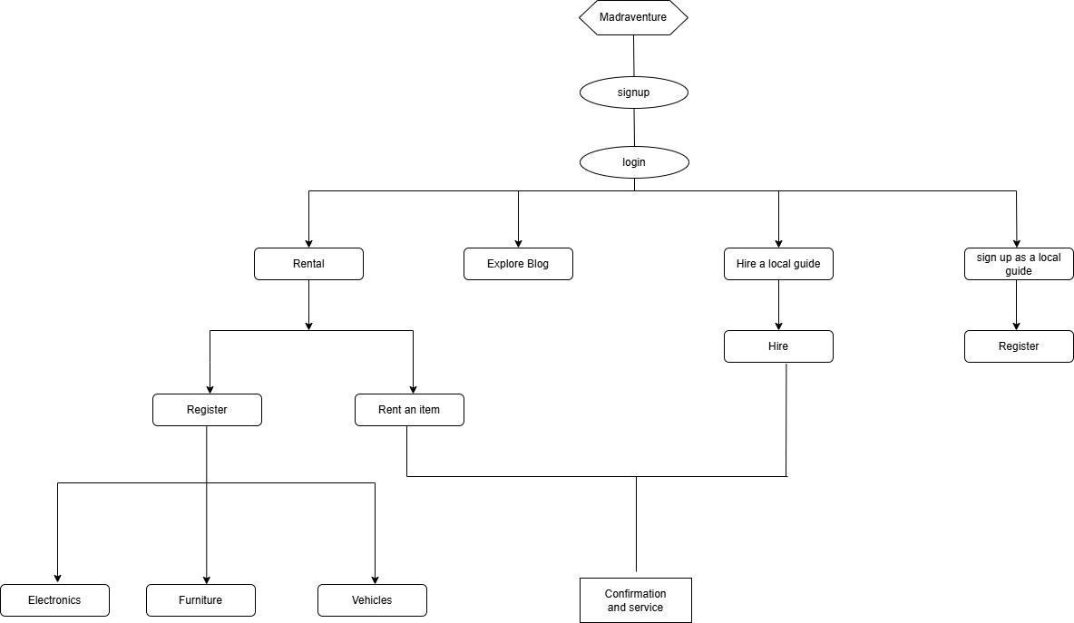

**5 Result and Discussion:**

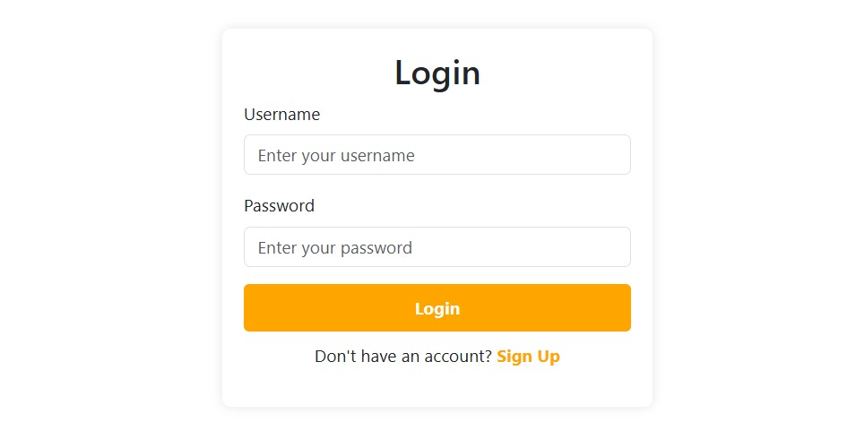

*Figure 1 login Screenshot*

Users provide their **registered username and password** on the login page. The credentials are passed to the backend, which verifies them against the MySQL database. In case they are correct, the user is redirected to his/her respective dashboard; otherwise, an error message is shown, providing a secure and efficient authentication process.  
  
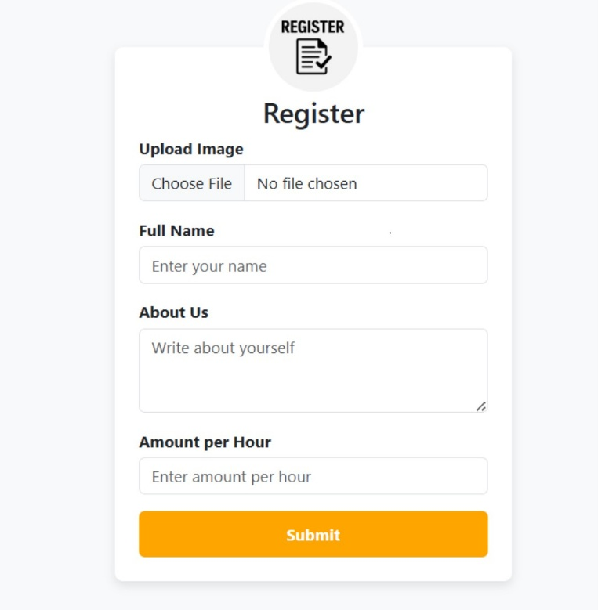

*Figure 2 local guide registration form screenshot*

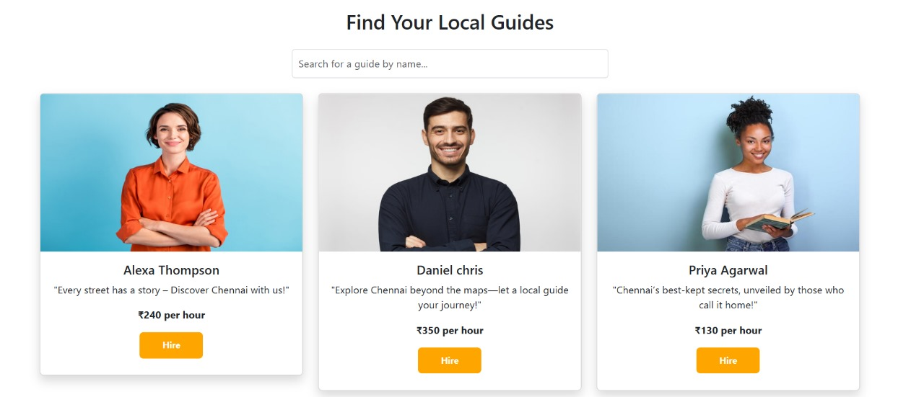  
 *Figure 4 local guide page Screenshot*

The Madraventure Local Guide Hiring Module provides the **facility to register as guides and facilitates tourists to search and hire them** according to their requirements. The module comprises two main functionalities: Guide Registration and Guide Listing & Hiring. Users who would like to provide local guide services can sign up by entering their full name, profile picture (saved using Base64 encoding in MySQL), description explaining their knowledge, local expertise, and languages they speak, and an hourly rate for the services. Once signed up, the information is saved in the **MySQL database**, and the guide is made bookable .Registered guides are shown in a specific section where travelers are able to browse through available guides. Guide information is retrieved from the database and dynamically shown on the frontend. Travelers can look at profiles, compare prices, and hire an appropriate guide for their travel. This module boosts local tourism by giving straight access to qualified guides, providing earning opportunities for locals and students while making sure tourists enjoy an authentic and informative traveling experience in Chennai.

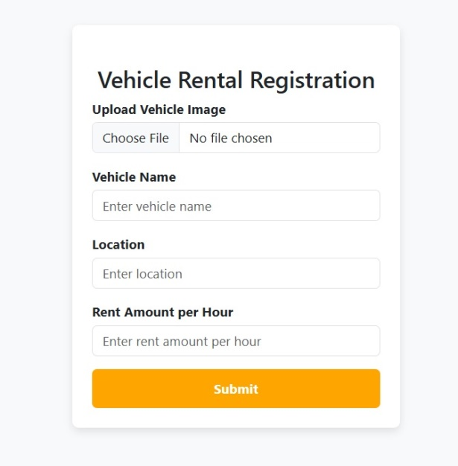

*Figure 5 vehicle registration form screenshot*

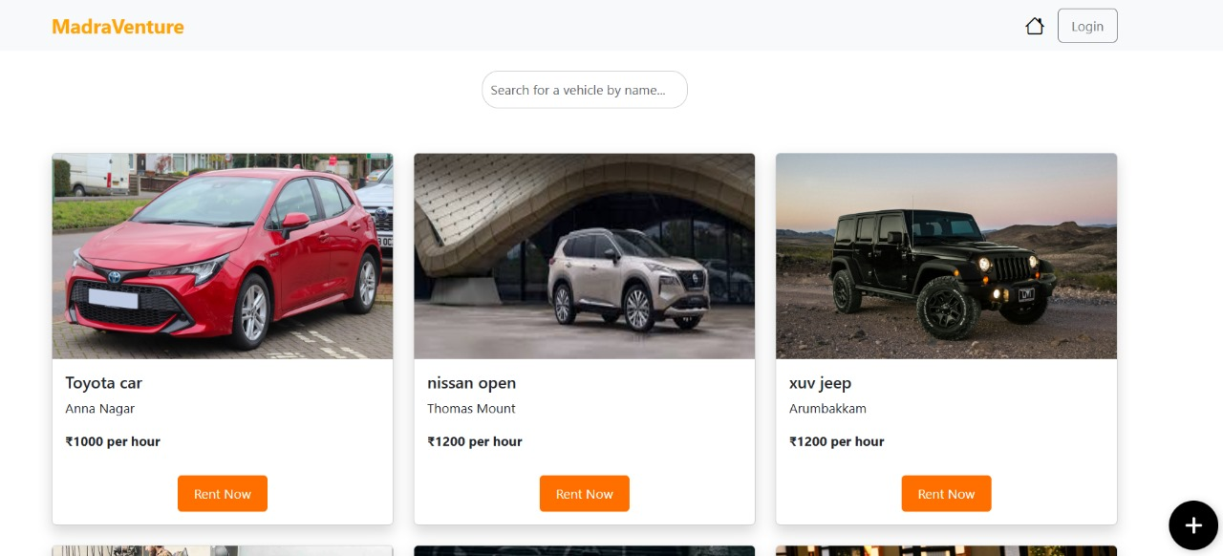

*Figure 6 vehicle rental page Screenshot*

The Madraventure Vehicle Rental Module allows the users to register their vehicles by entering information like vehicle name, image (stored with Base64 in MySQL), location, and rental cost per hour. It has two primary functionalities: **Vehicle Registration and Vehicle Listing & Hiring.** The registered vehicles are shown dynamically on the website, making tourists or locals **easily browse, compare, and rent a vehicle.**

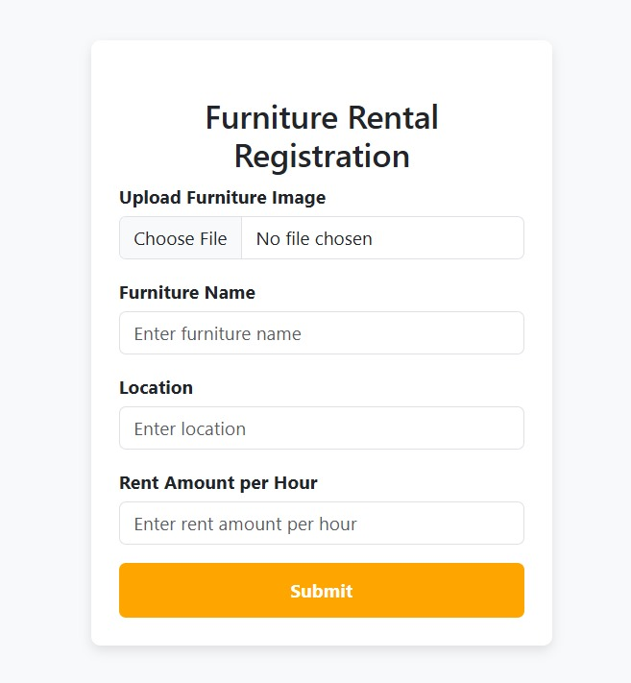

*Figure 7 furniture registration form screenshot*

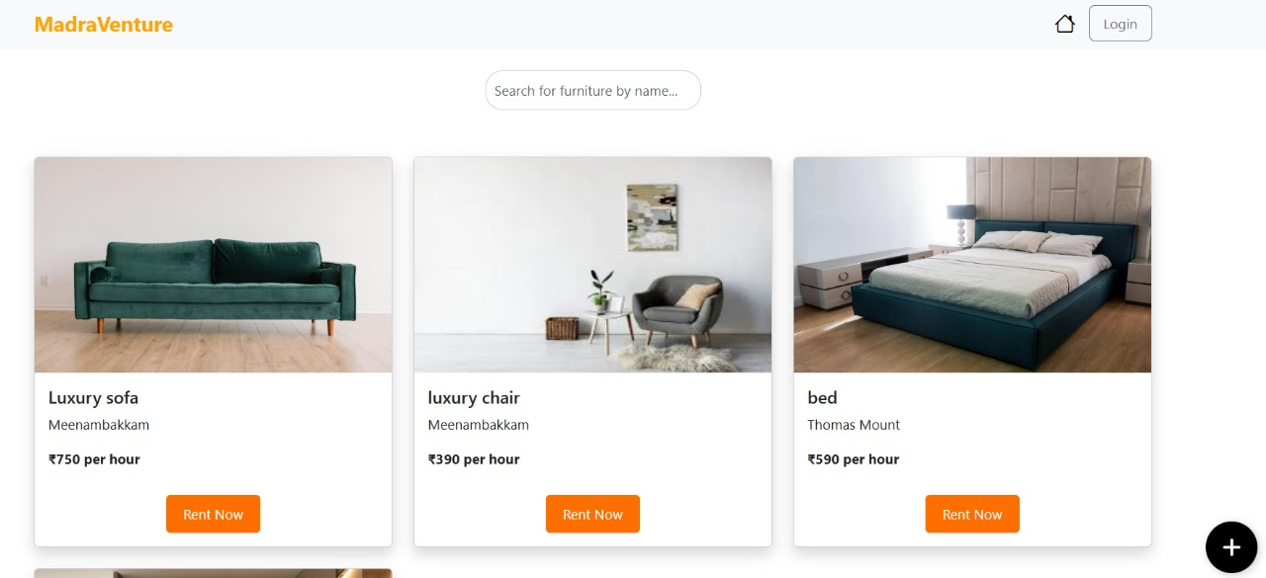

*Figure 8 furniture rental page Screenshot*

The Madraventure Furniture Rental Module permits the registration of furniture items by entering information like furniture name, image (saved with Base64 in MySQL), location, and per hour rental fee. The module supports two main functionalities: **Furniture Registration and Furniture Listing & Hiring**. Registered items are shown dynamically, allowing users to **view, compare prices, and hire furniture** hassle-free for residential, event, or office purposes.

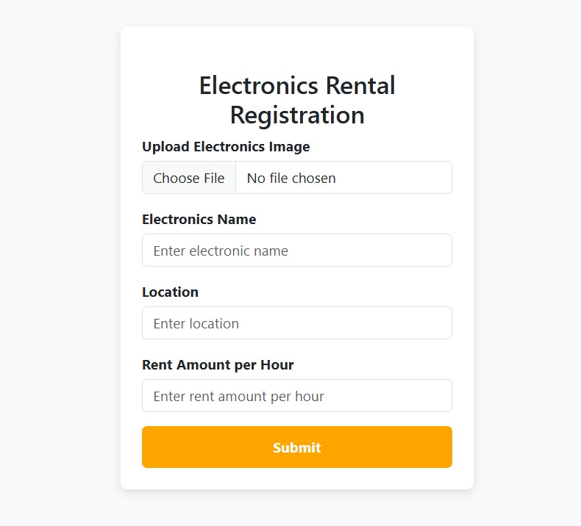

*Figure 9 electronics registration form screenshot*

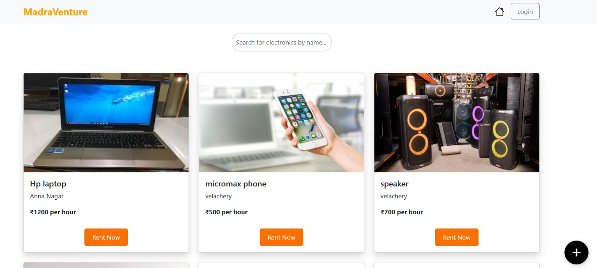

*Figure 10 electronics rental page Screenshot*

The Madraventure Electronics Rental Module allows users to register electronic devices by inputting information including item name, image (saved with Base64 in MySQL), location, and per hour rental fee. The module has two core functionalities: **Electronics Registration and Electronics Listing & Hiring.** Registered devices are displayed dynamically for users to **browse, compare, and hire gadgets or appliances** easily for private or business purposes.

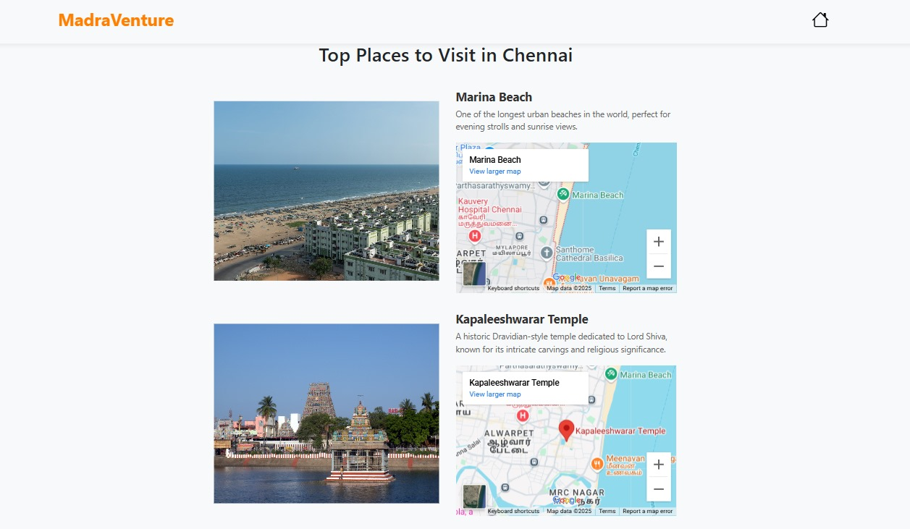 *Figure 11 explore Blog screenshot*

The Madraventure Explore Blog Module **features the best places to visit in Chennai**, allowing visitors to experience the city's rich heritage, history, and off-the-beaten-path sites. The module features a carefully selected list of must-see sites like Marina Beach, Kapaleeshwar Temple, Fort St. George. **Each site features a short description, photos, and an embedded map location for easy planning and navigation.**

**6 Conclusion**

Madraventure is a revolutionizing digital platform conceived to disrupt the tourism market in Chennai with an organized and ease-of-use experience for both visitors and service vendors. Incorporating a Local Guide Module, Rental Services, and an Explore Blog, the site facilitates enhanced accessibility to genuine tourism information resources with the aim of generating economic value for local citizens and students. In contrast to conventional methods of tourism that may encounter issues of a lack of transparency, untrustworthy services, and inefficient reservation mechanisms, Madraventure **provides a smooth, well-planned, and interactive traveling experience**.

Beyond just convenience, the platform contributes to local economic growth by empowering individuals to monetize their expertise and assets. With a strong emphasis on security, transparency, and user satisfaction, Madraventure is committed to evolving further to meet the dynamic needs of modern travelers. Future developments, including an admin interface, mobile app integration, and secure payment options**, will strengthen the platform’s operational efficiency, security, and user engagement,** making it a cornerstone of Chennai’s digital tourism ecosystem.

**6.1Future Enhancement**

***6.1.1 Admin Dashboard for Centralized Administration***

There will be a special admin interface to facilitate effective monitoring and administration of platform operations to provide users with a safe and smooth experience. The admin dashboard will feature:

*User Management*: View, update, and authenticate user accounts, such as tourists, guides, and rental owners.

*Guide & Rental Approval*: Accept or reject new guide registrations and rental postings to ensure quality control.

*Booking & Transaction Oversight*: Track rental bookings and steer hiring transactions for transparency.

*Analytics & Reports*: Provide reports on user activity, revenue, and platform performance.

***6.1.2 Secure Payment Integration***

For easy and secure transactions, a secure payment gateway will be integrated, enabling users to pay for guide services and rental bookings within the platform. Features will include:

*Encrypted Payment Processing*: Utilizing SSL/TLS encryption to secure transactions.

*Multiple Payment Options*: Accepting credit/debit cards, UPI, net banking, and digital wallets.

*Transaction History*: The users can see their payments and refunds in their account dashboard.

***6.1.3 Mobile App Development (Android & iOS)***

A specific mobile app will be created to increase accessibility, enabling users to book local guides, rent items, and view attractions while on the move. The app will provide:

*Simple UI/UX:* Smartphone-optimized with an interactive and responsive design.Location-Based *Services:* GPS-assisted recommendations of guides and local rental listings for enhanced user convenience.

**References**

[1] A Jauhari(2020). Development of a Smart Travel Guide App for Madura Island to Promote Tourism.<https://www.atlantis-press.com/>

[2] Mohana Priya,Vinoth kiron (2024).Smart Travel Guide Application: Enhancing Travel Experience through Real-time Navigation and AI Integration. <https://www.researchgate.net/publication/378715269>

[3] Preeti Harris,Rihan Siddhi,S Sricharan,B suntharam (2019). Bon Voyage: A Cross-Platform Web Application with Chatbot Integration for Travel Assistance.<http://www.irjet.net.com>

[4] Arun Krishna KV,Sabarish S (2021). Journey Companion: Android Travel and Tourism App with Integrated Services.<https://www.ijsepm.latticescipub.com/>

[5] Ardiansyah Dores(2020). Interactive Travel Guide Sharing Platform using Java, Spring Boot, and Vue.<https://www.researchgate.net/publication/348512607>